Midterm Project

CUNY DATA 624 - 2023 Summer I

Group 3: Daniel Sullivan, Jeff Parks, Lwin Shwe, Matthew Katz

## Objective

Praesent ac ipsum ut leo facilisis consequat. Sed aliquam odio vitae est volutpat, sed tincidunt eros imperdiet. Maecenas sit amet dictum massa. Cras ultricies neque lorem, in fermentum turpis venenatis nec. Aenean non diam interdum, tincidunt dui in, maximus orci. Praesent eget enim id erat volutpat euismod. Vivamus euismod turpis nec sollicitudin accumsan. Duis maximus finibus auctor. Phasellus quis ornare nunc, id porttitor elit. Donec sit amet vulputate arcu. Nulla sodales lacinia nisl, sed hendrerit ex consectetur eget.

## Category 01

Praesent ac ipsum ut leo facilisis consequat. Sed aliquam odio vitae est volutpat, sed tincidunt eros imperdiet. Maecenas sit amet dictum massa. Cras ultricies neque lorem, in fermentum turpis venenatis nec.

### Variable 01

Praesent ac ipsum ut leo facilisis consequat. Sed aliquam odio vitae est volutpat, sed tincidunt eros imperdiet. Maecenas sit amet dictum massa. Cras ultricies neque lorem, in fermentum turpis venenatis nec.

#### Analysis

#### Forecast

### Variable 02

#### Analysis

#### Forecast

## Category 02

df_s02 <- df %>%  
 filter(category == 'S02') %>%  
 select(c(Date,Var02,Var03)) %>%  
 head(1622)  
  
ts_s02_v02 <- df_s02 %>%  
 select(dates=Date,values=Var02) %>%  
 drop_na() %>%  
 expand_dates()  
  
ts_s02_v03 <- df_s02 %>%  
 select(dates=Date,values=Var03) %>%  
 drop_na() %>%  
 expand_dates()

### Variable 02

# 7-MA moving average  
ts_s02_v02_ma7 <- ma(ts_s02_v02, order=7, centre=TRUE)  
autoplot(ts_s02_v02_ma7)

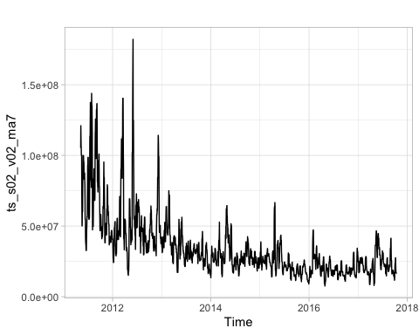

#### Analysis

#### Forecast

### Variable 03

#### Analysis

#### Forecast

## Category 03

### Variable 05

#### Analysis

#### Forecast

### Variable 07

#### Analysis

#### Forecast

## Category 04

### Variable 01

#### Analysis

#### Forecast

### Variable 02

#### Analysis

#### Forecast

## Category 05

### Variable 02

#### Analysis

#### Forecast

### Variable 03

#### Analysis

#### Forecast

## Category 06

### Variable 02

#### Analysis

#### Forecast

### Variable 03

#### Analysis

#### Forecast

## Conclusions

## Appendix

### R Code